FLOW CHART

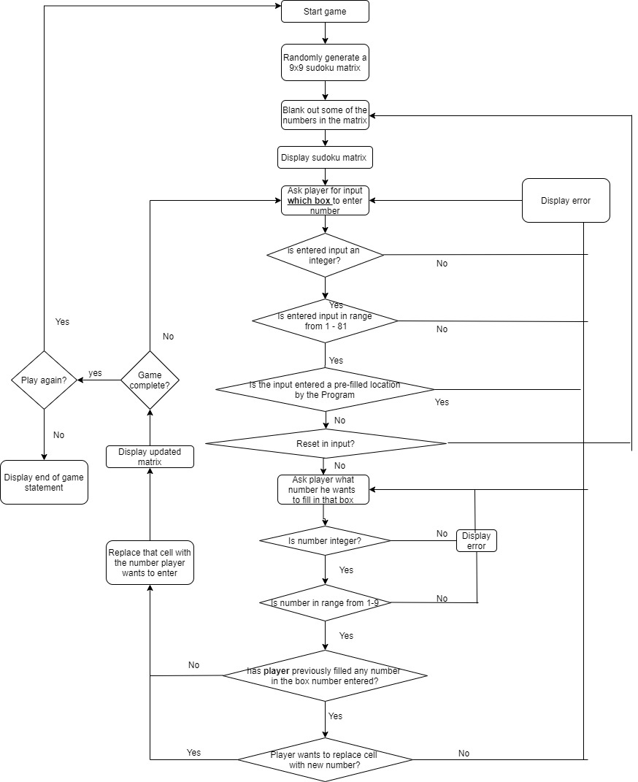

|  |  |  |  |
| --- | --- | --- | --- |
| SUDOKU | | | |
| S \ no. | Test cases | Expected result | Actual result | |
|  | Enter name of game | Show welcome display |  |
|  | Enter cell number player wants to make move in – enter invalid character (anything that is not numeric or not in range from 1 -81) | Display error &prompt me to re-enter |  |
|  | Enter cell number player wants to make move in – enter valid character (anything that is numeric and in range from 1 -81) | Move on to next step. |  |
|  | Enter cell no. in which player has previously made a move | Confirm with player if he wants to replace the number in that cell |  |
|  | Enter cell no. in which program has already filled a number | Display error and prompt user to re-enter cell-number |  |
|  | Enter invalid number to place in cell (anything not numeric or not in range 1-9) | Display  Error.  Prompt player to re-enter number |  |

|  |  |  |  |  |  |
| --- | --- | --- | --- | --- | --- |
|  | Enter valid number to place in cell (anything numeric and in range 1-9) | Move on to next step and display newly-updated matrix |  | | |
|  | Enter “reset” | Reset the game and display the matrix |  | 🡪 |  |
|  | Player solve the sudoku game | Display congratulation message and end of game msg. |  | | |
|  | Player wants to quit | Quit message |  | | |

|  |  |
| --- | --- |
| Log count | LOGS |
| 1 | ..................................................  | 1 | 3 | 5 | | 9 | 4 | 8 | 2 | 7 |  ..................................................  | 6 | 9 | 4 | 8 | | 7 | 1 | 3 | 5 |  ....................................  | 8 | 2 | 7 | 1 | 3 | 5 | 6 | | 4 |  ....................................  | 2 | 7 | 1 | 3 | | 6 | 9 | 4 | 8 |  ....................................  | 3 | 5 | 6 | 9 | 4 | | 2 | 7 | 1 |  ....................................  | 9 | 4 | 8 | 2 | 7 | 1 | 3 | 5 | |  ....................................  | | 8 | 2 | 7 | 1 | 3 | 5 | 6 | 9 |  ....................................  | 7 | | 3 | 5 | 6 | 9 | 4 | 8 | 2 |  ....................................  | 5 | 6 | 9 | 4 | 8 | 2 | | 1 | 3 |  ....................................  WHICH BOX(1 - 81) DO YOU WANT TO ENTER YOUR NUMBER IN: 4  WHICH NUMBER (1-9) DO YOU WANT TO ENTER IN BOX NUMBER 4: 6  ....................................  | 1 | 3 | 5 | 6 | 9 | 4 | 8 | 2 | 7 |  ....................................  | 6 | 9 | 4 | 8 | | 7 | 1 | 3 | 5 |  ....................................  | 8 | 2 | 7 | 1 | 3 | 5 | 6 | | 4 |  ....................................  | 2 | 7 | 1 | 3 | | 6 | 9 | 4 | 8 |  ....................................  | 3 | 5 | 6 | 9 | 4 | | 2 | 7 | 1 |  ....................................  | 9 | 4 | 8 | 2 | 7 | 1 | 3 | 5 | |  ....................................  | | 8 | 2 | 7 | 1 | 3 | 5 | 6 | 9 |  ....................................  | 7 | | 3 | 5 | 6 | 9 | 4 | 8 | 2 |  ....................................  | 5 | 6 | 9 | 4 | 8 | 2 | | 1 | 3 |  ....................................  WHICH BOX(1 - 81) DO YOU WANT TO ENTER YOUR NUMBER IN: 5  SORRY, YOU CANNOT ENTER "5"; YOU CAN ONLY ENTER NUMBERS FOR BOXES IN RANGE FROM 1 - 81  WHICH BOX(1 - 81) DO YOU WANT TO ENTER YOUR NUMBER IN: 123  SORRY, YOU CANNOT ENTER "123"; YOU CAN ONLY ENTER NUMBERS FOR BOXES IN RANGE FROM 1 - 81  WHICH BOX(1 - 81) DO YOU WANT TO ENTER YOUR NUMBER IN: 4  WHICH NUMBER (1-9) DO YOU WANT TO ENTER IN BOX NUMBER 4: 6  ARE YOU SURE THAT YOU WANT TO REPLACE THE NUMBER IN BOX 4: y  ....................................  | 1 | 3 | 5 | 6 | 9 | 4 | 8 | 2 | 7 |  ....................................  | 6 | 9 | 4 | 8 | | 7 | 1 | 3 | 5 |  ....................................  | 8 | 2 | 7 | 1 | 3 | 5 | 6 | | 4 |  ....................................  | 2 | 7 | 1 | 3 | | 6 | 9 | 4 | 8 |  ....................................  | 3 | 5 | 6 | 9 | 4 | | 2 | 7 | 1 |  ....................................  | 9 | 4 | 8 | 2 | 7 | 1 | 3 | 5 | |  ....................................  | | 8 | 2 | 7 | 1 | 3 | 5 | 6 | 9 |  ....................................  | 7 | | 3 | 5 | 6 | 9 | 4 | 8 | 2 |  ....................................  | 5 | 6 | 9 | 4 | 8 | 2 | | 1 | 3 |  ....................................  WHICH BOX(1 - 81) DO YOU WANT TO ENTER YOUR NUMBER IN: 15  SORRY, YOU CANNOT ENTER "15"; YOU CAN ONLY ENTER NUMBERS FOR BOXES IN RANGE FROM 1 - 81  WHICH BOX(1 - 81) DO YOU WANT TO ENTER YOUR NUMBER IN:  SORRY, YOU CANNOT ENTER ""; YOU CAN ONLY ENTER NUMBERS FOR BOXES IN RANGE FROM 1 - 81  WHICH BOX(1 - 81) DO YOU WANT TO ENTER YOUR NUMBER IN: 2  SORRY, YOU CANNOT ENTER "2"; YOU CAN ONLY ENTER NUMBERS FOR BOXES IN RANGE FROM 1 - 81  WHICH BOX(1 - 81) DO YOU WANT TO ENTER YOUR NUMBER IN: 14  WHICH NUMBER (1-9) DO YOU WANT TO ENTER IN BOX NUMBER 14: 2  ....................................  | 1 | 3 | 5 | 6 | 9 | 4 | 8 | 2 | 7 |  ....................................  | 6 | 9 | 4 | 8 | 2 | 7 | 1 | 3 | 5 |  ....................................  | 8 | 2 | 7 | 1 | 3 | 5 | 6 | | 4 |  ....................................  | 2 | 7 | 1 | 3 | | 6 | 9 | 4 | 8 |  ....................................  | 3 | 5 | 6 | 9 | 4 | | 2 | 7 | 1 |  ....................................  | 9 | 4 | 8 | 2 | 7 | 1 | 3 | 5 | |  ....................................  | | 8 | 2 | 7 | 1 | 3 | 5 | 6 | 9 |  ....................................  | 7 | | 3 | 5 | 6 | 9 | 4 | 8 | 2 |  ....................................  | 5 | 6 | 9 | 4 | 8 | 2 | | 1 | 3 |  ....................................  WHICH BOX(1 - 81) DO YOU WANT TO ENTER YOUR NUMBER IN: 26  WHICH NUMBER (1-9) DO YOU WANT TO ENTER IN BOX NUMBER 26: 9  ....................................  | 1 | 3 | 5 | 6 | 9 | 4 | 8 | 2 | 7 |  ....................................  | 6 | 9 | 4 | 8 | 2 | 7 | 1 | 3 | 5 |  ....................................  | 8 | 2 | 7 | 1 | 3 | 5 | 6 | 9 | 4 |  ....................................  | 2 | 7 | 1 | 3 | | 6 | 9 | 4 | 8 |  ....................................  | 3 | 5 | 6 | 9 | 4 | | 2 | 7 | 1 |  ....................................  | 9 | 4 | 8 | 2 | 7 | 1 | 3 | 5 | |  ....................................  | | 8 | 2 | 7 | 1 | 3 | 5 | 6 | 9 |  ....................................  | 7 | | 3 | 5 | 6 | 9 | 4 | 8 | 2 |  ....................................  | 5 | 6 | 9 | 4 | 8 | 2 | | 1 | 3 |  ....................................  WHICH BOX(1 - 81) DO YOU WANT TO ENTER YOUR NUMBER IN: 32  WHICH NUMBER (1-9) DO YOU WANT TO ENTER IN BOX NUMBER 32: 5  ....................................  | 1 | 3 | 5 | 6 | 9 | 4 | 8 | 2 | 7 |  ....................................  | 6 | 9 | 4 | 8 | 2 | 7 | 1 | 3 | 5 |  ....................................  | 8 | 2 | 7 | 1 | 3 | 5 | 6 | 9 | 4 |  ....................................  | 2 | 7 | 1 | 3 | 5 | 6 | 9 | 4 | 8 |  ....................................  | 3 | 5 | 6 | 9 | 4 | | 2 | 7 | 1 |  ....................................  | 9 | 4 | 8 | 2 | 7 | 1 | 3 | 5 | |  ....................................  | | 8 | 2 | 7 | 1 | 3 | 5 | 6 | 9 |  ....................................  | 7 | | 3 | 5 | 6 | 9 | 4 | 8 | 2 |  ....................................  | 5 | 6 | 9 | 4 | 8 | 2 | | 1 | 3 |  ....................................  WHICH BOX(1 - 81) DO YOU WANT TO ENTER YOUR NUMBER IN: 54  WHICH NUMBER (1-9) DO YOU WANT TO ENTER IN BOX NUMBER 54: 6  ....................................  | 1 | 3 | 5 | 6 | 9 | 4 | 8 | 2 | 7 |  ....................................  | 6 | 9 | 4 | 8 | 2 | 7 | 1 | 3 | 5 |  ....................................  | 8 | 2 | 7 | 1 | 3 | 5 | 6 | 9 | 4 |  ....................................  | 2 | 7 | 1 | 3 | 5 | 6 | 9 | 4 | 8 |  ....................................  | 3 | 5 | 6 | 9 | 4 | | 2 | 7 | 1 |  ....................................  | 9 | 4 | 8 | 2 | 7 | 1 | 3 | 5 | 6 |  ....................................  | | 8 | 2 | 7 | 1 | 3 | 5 | 6 | 9 |  ....................................  | 7 | | 3 | 5 | 6 | 9 | 4 | 8 | 2 |  ....................................  | 5 | 6 | 9 | 4 | 8 | 2 | | 1 | 3 |  ....................................  WHICH BOX(1 - 81) DO YOU WANT TO ENTER YOUR NUMBER IN: 42  WHICH NUMBER (1-9) DO YOU WANT TO ENTER IN BOX NUMBER 42: 8  ....................................  | 1 | 3 | 5 | 6 | 9 | 4 | 8 | 2 | 7 |  ....................................  | 6 | 9 | 4 | 8 | 2 | 7 | 1 | 3 | 5 |  ....................................  | 8 | 2 | 7 | 1 | 3 | 5 | 6 | 9 | 4 |  ....................................  | 2 | 7 | 1 | 3 | 5 | 6 | 9 | 4 | 8 |  ....................................  | 3 | 5 | 6 | 9 | 4 | 8 | 2 | 7 | 1 |  ....................................  | 9 | 4 | 8 | 2 | 7 | 1 | 3 | 5 | 6 |  ....................................  | | 8 | 2 | 7 | 1 | 3 | 5 | 6 | 9 |  ....................................  | 7 | | 3 | 5 | 6 | 9 | 4 | 8 | 2 |  ....................................  | 5 | 6 | 9 | 4 | 8 | 2 | | 1 | 3 |  ....................................  WHICH BOX(1 - 81) DO YOU WANT TO ENTER YOUR NUMBER IN: 55  WHICH NUMBER (1-9) DO YOU WANT TO ENTER IN BOX NUMBER 55: 4  ....................................  | 1 | 3 | 5 | 6 | 9 | 4 | 8 | 2 | 7 |  ....................................  | 6 | 9 | 4 | 8 | 2 | 7 | 1 | 3 | 5 |  ....................................  | 8 | 2 | 7 | 1 | 3 | 5 | 6 | 9 | 4 |  ....................................  | 2 | 7 | 1 | 3 | 5 | 6 | 9 | 4 | 8 |  ....................................  | 3 | 5 | 6 | 9 | 4 | 8 | 2 | 7 | 1 |  ....................................  | 9 | 4 | 8 | 2 | 7 | 1 | 3 | 5 | 6 |  ....................................  | 4 | 8 | 2 | 7 | 1 | 3 | 5 | 6 | 9 |  ....................................  | 7 | | 3 | 5 | 6 | 9 | 4 | 8 | 2 |  ....................................  | 5 | 6 | 9 | 4 | 8 | 2 | | 1 | 3 |  ....................................  WHICH BOX(1 - 81) DO YOU WANT TO ENTER YOUR NUMBER IN: 65  WHICH NUMBER (1-9) DO YOU WANT TO ENTER IN BOX NUMBER 65: 1  ....................................  | 1 | 3 | 5 | 6 | 9 | 4 | 8 | 2 | 7 |  ....................................  | 6 | 9 | 4 | 8 | 2 | 7 | 1 | 3 | 5 |  ....................................  | 8 | 2 | 7 | 1 | 3 | 5 | 6 | 9 | 4 |  ....................................  | 2 | 7 | 1 | 3 | 5 | 6 | 9 | 4 | 8 |  ....................................  | 3 | 5 | 6 | 9 | 4 | 8 | 2 | 7 | 1 |  ....................................  | 9 | 4 | 8 | 2 | 7 | 1 | 3 | 5 | 6 |  ....................................  | 4 | 8 | 2 | 7 | 1 | 3 | 5 | 6 | 9 |  ....................................  | 7 | 1 | 3 | 5 | 6 | 9 | 4 | 8 | 2 |  ....................................  | 5 | 6 | 9 | 4 | 8 | 2 | | 1 | 3 |  ....................................  WHICH BOX(1 - 81) DO YOU WANT TO ENTER YOUR NUMBER IN: 79  WHICH NUMBER (1-9) DO YOU WANT TO ENTER IN BOX NUMBER 79: 7  ....................................  | 1 | 3 | 5 | 6 | 9 | 4 | 8 | 2 | 7 |  ....................................  | 6 | 9 | 4 | 8 | 2 | 7 | 1 | 3 | 5 |  ....................................  | 8 | 2 | 7 | 1 | 3 | 5 | 6 | 9 | 4 |  ....................................  | 2 | 7 | 1 | 3 | 5 | 6 | 9 | 4 | 8 |  ....................................  | 3 | 5 | 6 | 9 | 4 | 8 | 2 | 7 | 1 |  ....................................  | 9 | 4 | 8 | 2 | 7 | 1 | 3 | 5 | 6 |  ....................................  | 4 | 8 | 2 | 7 | 1 | 3 | 5 | 6 | 9 |  ....................................  | 7 | 1 | 3 | 5 | 6 | 9 | 4 | 8 | 2 |  ....................................  | 5 | 6 | 9 | 4 | 8 | 2 | 7 | 1 | 3 |  ....................................  WELL DONE!, YOU HAVE CORRECTLY SOLVED THE SUDOKU PUZZEL!  DO YOU WANT TO PLAY AGAIN: n  >>> |